“Raceway Design”
Subject: Bearing Design
Bearing operation is often a balance between stress and heat generation, with complex solutions. The raceway design of a ball bearing is crucial to the tradeoff between stress and heat generation, a designer needs to know how it plays such an important role to be able to understand bearing operation. The physical geometry that controls this is the cross-raceway curvature, defined as a percentage of ball diameter. The targeted design value for raceway curvature and manufacturing variability can play a large role in a bearing’s operating performance. Therefore, control limits are also important.

Raceway Curvature
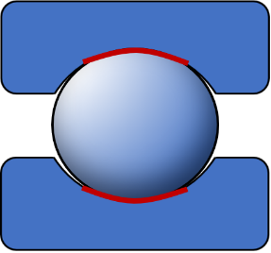
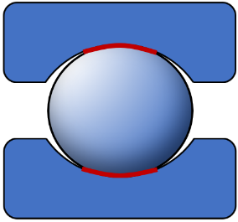
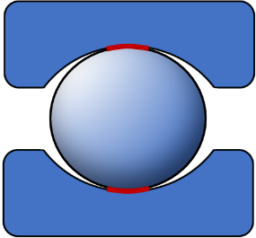
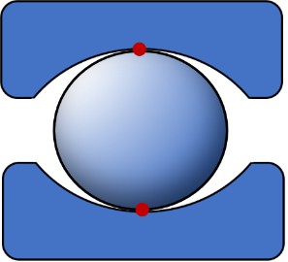
When the ratio is small, as seen below on the left, the race will tightly conform to the ball, as opposed to the bearing on the far right which loosely conforms to the ball radius. At a high level, the more surface area between two contacting surfaces the less stress (loads will distribute better) and vice versa. Accordingly, more surface area contact carries along with it more friction thus more heat generation. So, when the raceway conforms tighter to the ball it will have less stress but potentially more heat generation, and when the raceway loosely conforms to the ball stress will increase but frictional torque and heat generation may decrease.
Increasing Curvature

Min Stress
&
Max Heat Generation
Max Stress
&
Min Heat Generation

Raceway Design Considerations
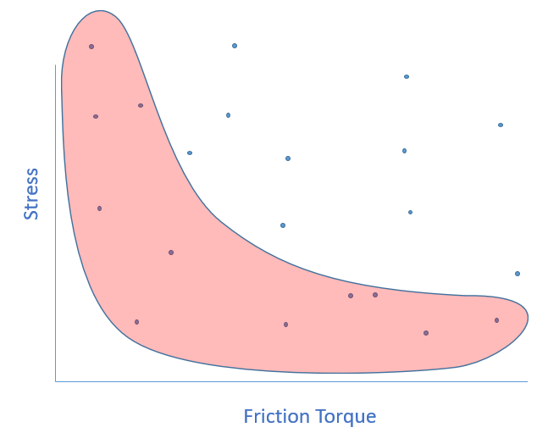
The raceway design is dependent on the goals for the bearing in a certain application. If maximum capacity for high fatigue life is required, curvatures should be minimized, but raceway curvature should not be too small so that excessive non-rolling action (spinning and sliding) occurs resulting in too much heat generation and wear. On the other hand, if minimum friction torque is a priority, then maximizing curvatures within the limitation for fatigue life is executed. For optimum design of the raceways, the curvatures must be analyzed together with ball size and diametral clearance to achieve required life with acceptable amounts of ball spin (friction).

Contact NES
For help selecting the proper raceway curvatures for your application contact NES bearing application and design engineers Andrew Hvizdzak (ahvizdzak@nesbearings.com) or Tim Asquith (tasquith@nesbearings.com).

